Google Classroom

**Online Learning Platform**

Use-Case-Realization Specification: Take quiz

Version 1.1

Revision History

|  |  |  |  |
| --- | --- | --- | --- |
| **Date** | **Version** | **Description** | **Author** |
| 05/12/2021 | 1.0 | Initial version | Nguyen Tuan Nghia |
| 09/12/2021 | 1.1 | Final version | Nguyen Tuan Nghia |
|  |  |  |  |
|  |  |  |  |

Table of Contents

1. Introduction 2

1.1 Purpose 2

1.2 Scope 2

1.3 Definitions, Acronyms, and Abbreviations 2

1.4 References 2

1.5 Overview 2

2. Flow of Events—Design 2

3. Derived Requirements 2

Use-Case-Realization Specification: Manage Post

# Introduction

## Purpose

This Use-case Realization Specification provides an overview of how the corresponding use-case is realized to the design model in terms of collaborating objects.

## Scope

This document only applies to the Use-case: Take Quiz

## Definitions, Acronyms, and Abbreviations

None

## References

## Overview

In part 2, the use-case realization will be further illustrated by using class diagrams and sequence diagrams. Later on, from the realized diagrams, other requirements that have not been considered in the design model will be listed in section 3 – Derived Requirements.

# Flow of Events—Design

There are four types of object this use-case realization. They include: Student View, Quiz Controller, Quiz Model which is a data access class. The sequence in which the operations are invoked is realized according to Model-View-Controller architecture.

## sequence diagram

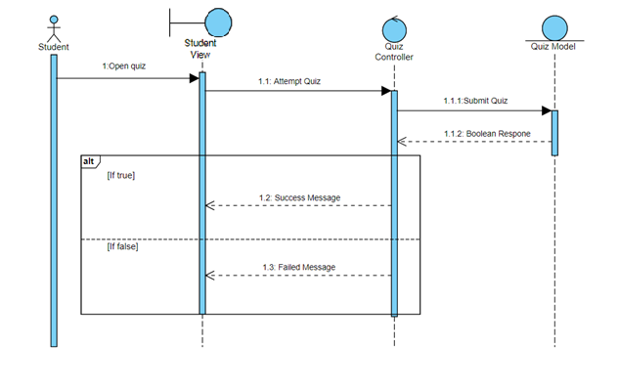

## class diagram

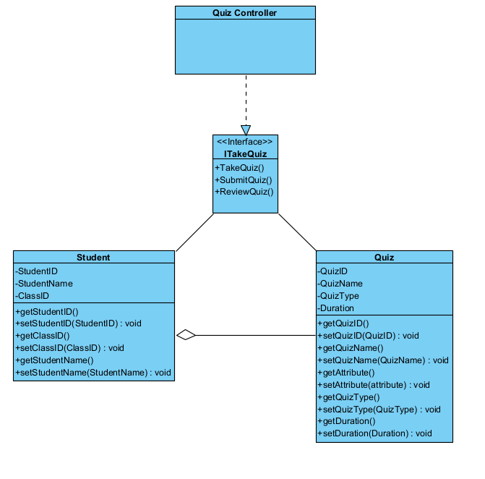

# Derived Requirements